ApexPlanet Data Analytics Internship
Task 2: Exploratory Data Analysis (EDA) & Business Intelligence

Task: Task 2 – Exploratory Data Analysis (EDA) & Business Intelligence
Submitted By: P. Jeevana
Internship: ApexPlanet Software Pvt. Ltd.
Submission Date: 25/07/2026

1. Objective
The objective of this task is to perform Exploratory Data Analysis (EDA) on the cleaned dataset prepared in Task 1. The analysis focuses on understanding the sales data by identifying patterns, trends, and relationships using Microsoft Excel and SQL Server. This task also involves answering business questions using SQL queries and creating a static dashboard to present important business metrics in a clear and meaningful way.
2. Dataset Overview
The dataset used for this task is ApexPlanet_DataAnalytics_Cleaned.xlsx, which was prepared during Task 1 after completing the data cleaning and feature engineering process. The cleaned dataset was used for all the analyses performed in this task.
Dataset Details
- Number of Rows: 1000
- Number of Columns: 15
Dataset Columns
- Order_ID
- Order_Date
- Customer_ID
- Customer_Name
- Age
- Gender
- City
- Product
- Category
- Quantity
- Unit_Price
- Total_Sales
- Order_Month
- Order_Year
- Order_Quarter
3. Tools Used
The following tools were used to complete this task:
- Microsoft Excel
- Microsoft SQL Server Management Studio (SSMS)
- SQL
- Pivot Tables
- Pivot Charts
- Data Analysis ToolPak
- Conditional Formatting
These tools were used for data analysis, visualization, SQL query execution, and dashboard creation.
4. Exploratory Data Analysis (EDA)
The cleaned dataset was analysed using Microsoft Excel to understand the sales data and identify useful business insights. Different Excel features such as Pivot Tables, Pivot Charts, Data Analysis ToolPak, and Conditional Formatting were used to perform the analysis.
The following analyses were completed:
4.1. Descriptive Statistics
The Descriptive Statistics tool available in the Excel Data Analysis ToolPak was used to generate a statistical summary of the numerical columns in the dataset.
This analysis provided an overview of the numerical data and helped in understanding the dataset before creating charts and performing further analysis.
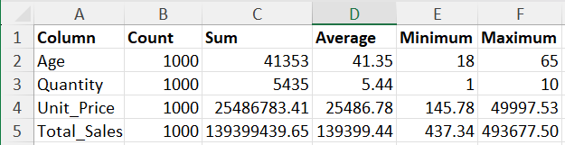
Figure 4.1: Descriptive Statistics
4.2. Gender Analysis
A Pivot Table was created to analyse Total Sales based on customer gender.
A Pivot Charts(Bar Chart) was created from the Pivot Table to compare the sales of male and female customers.
This analysis helped compare the sales contribution of each gender.
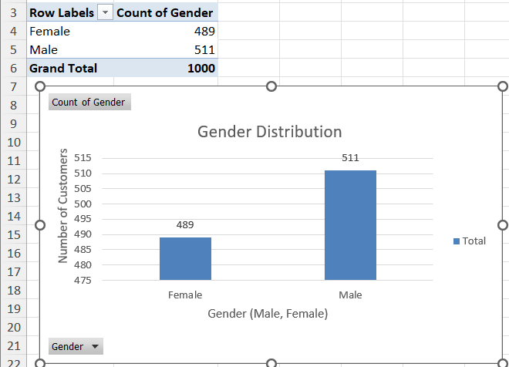
Figure 4.2: Gender-wise Sales Analysis
4.3. Category Analysis
A Pivot Table was created to calculate Total Sales for each product category.
A Pivot Charts(Bar Chart) was created to compare sales across different categories.
This analysis helped identify the categories generating higher sales.
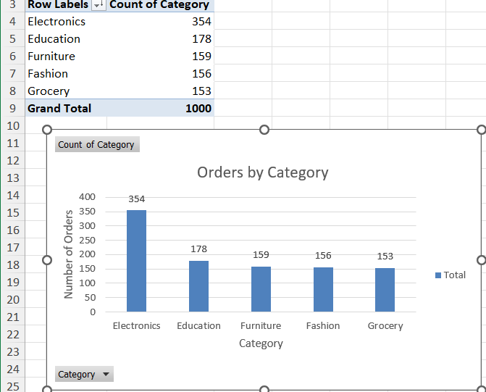
Figure 4.3: Category-wise Sales Analysis
4.4. City Analysis
A Pivot Table was created to calculate Total Sales for each city.
A Pivot Charts(Bar Chart) was created to compare sales across different cities.
This analysis helped identify cities with better sales performance.
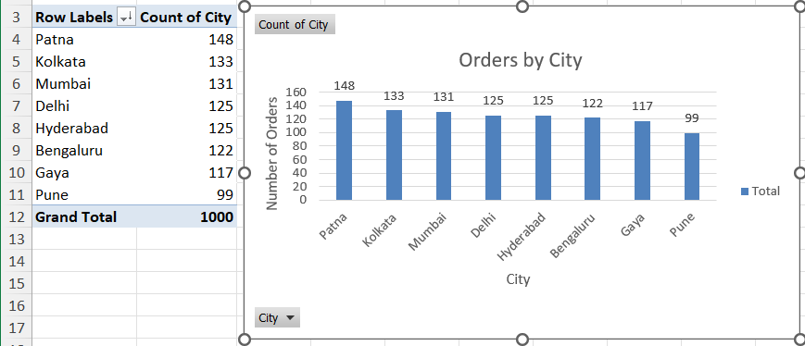
Figure 4.4: City-wise Sales Analysis
4.5. Product Analysis
A Pivot Table was created to calculate Total Sales for each product.
A Pivot Charts(Bar Chart) was created to compare sales among different products.
This analysis helped identify the products contributing more to total sales.
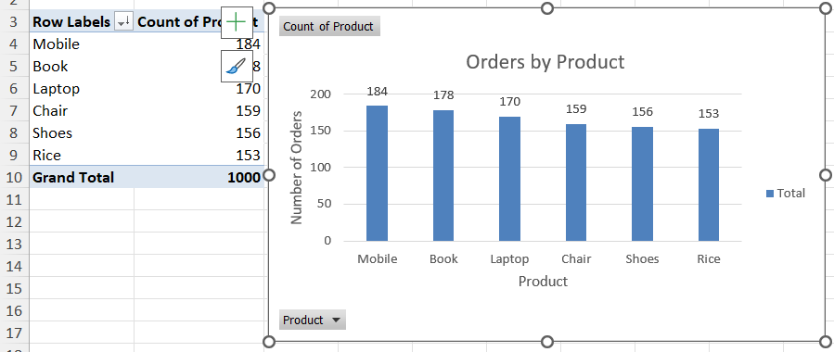
Figure 4.5: Product-wise Sales Analysis
4.6. Histogram Analysis
Histograms were created using the Excel Data Analysis ToolPak for the following numerical columns:
- Age
- Quantity
- Unit_Price
- Total_Sales
These histograms helped understand the distribution of the numerical values in the dataset.
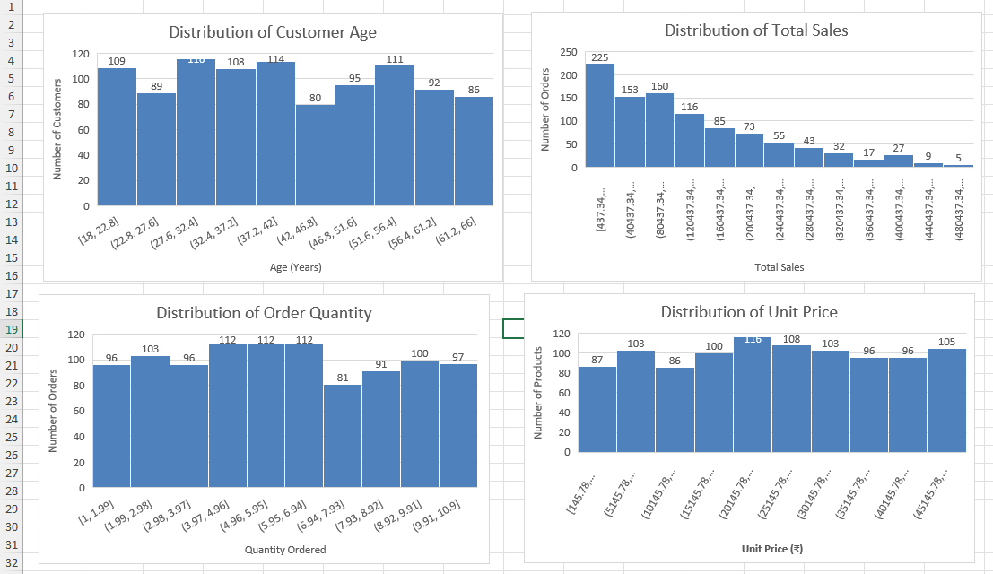
Figure 4.6: Histogram Analysis
5. SQL Business Questions
The cleaned dataset was imported into Microsoft SQL Server Management Studio (SSMS) to perform business analysis. SQL queries were written and executed to answer different business questions using the sales data.
The following business questions were answered:

5.1. Total Records
A SQL query was executed to calculate the total number of records available in the dataset.
This query helped verify the number of sales transactions present in the cleaned dataset.
5.2. Total Orders
A SQL query was used to calculate the total number of orders.
This analysis provided the total orders recorded in the dataset.
5.3. Total Revenue
A SQL query was executed to calculate the total revenue generated from all sales transactions.
This analysis helped determine the overall sales revenue.
5.4. Orders by Category
A SQL query was written to calculate the total number of orders for each product category.
This analysis helped compare the performance of different product categories.
5.5. Highest Revenue City
A SQL query was executed to identify the city that generated the highest total revenue.
This analysis helped identify the city with the best sales performance.
5.6. Average Order Value
A SQL query was used to calculate the average order value.
This analysis provided the average sales amount per order.

5.7. Top 5 Products by Revenue
A SQL query was executed to identify the top five products based on total revenue.
This analysis helped identify the highest-performing products.
5.8. Average Age by Gender
A SQL query was used to calculate the average age of customers based on gender.
This analysis provided information about the customer demographics.
5.9. Highest Average Sales by City
A SQL query was executed to identify the city with the highest average sales value.
This analysis helped compare the average sales performance across different cities.
5.10. Total Quantity Sold
A SQL query was used to calculate the total quantity of products sold.
This analysis helped determine the overall quantity sold during the sales period.
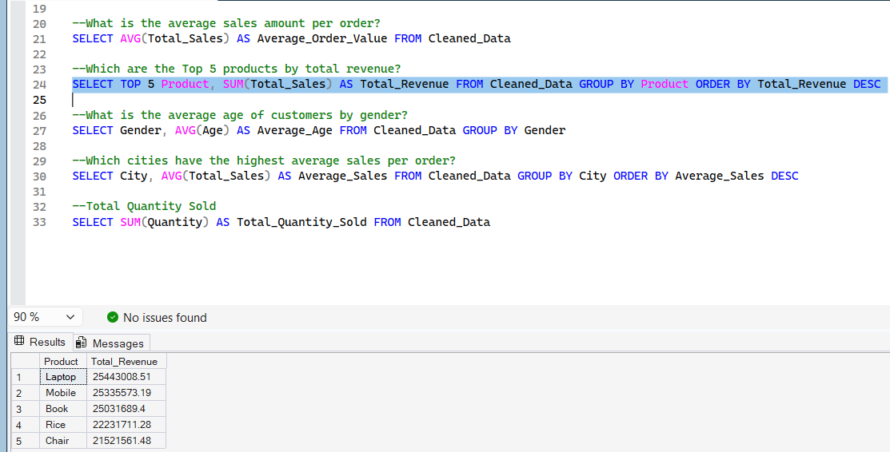
Figure 5: SQL Query Execution and Result (Top 5 Products by Revenue)
6. Multivariate Analysis & Correlation
To understand the relationship between different numerical variables, multivariate analysis was performed using Microsoft Excel.
The following analyses were completed:
6.1. Scatter Plot
A Scatter Plot was created to analyse the relationship between Age and Total_Sales.
This chart helped visualize how customer age is related to the total sales amount.
Figure 6.1: Scatter Plot (Age vs Total Sales)
6.2. Correlation Matrix
A Correlation Matrix was generated using the Data Analysis ToolPak in Microsoft Excel.
The following numerical columns were included in the analysis:
- Age
- Quantity
- Unit_Price
- Total_Sales
The Correlation Matrix was used to measure the relationship between these numerical variables.
The analysis showed the following relationships:
- Quantity has a positive correlation with Total_Sales.
- Unit_Price has a positive correlation with Total_Sales.
- Age has a very weak correlation with Total_Sales.
These results indicate that Quantity and Unit Price have a greater influence on Total Sales.
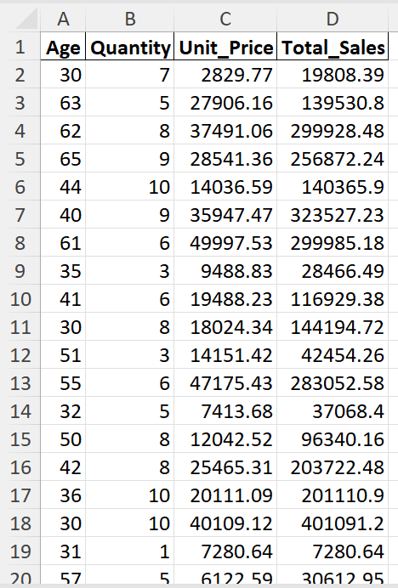
Figure 6.2: Correlation Matrix
6.3. Heatmap
A Heatmap was created using Conditional Formatting on the Correlation Matrix.
The Heatmap provides a visual representation of the correlation values by highlighting stronger and weaker relationships between the numerical variables.
This visualization makes it easier to understand the correlation between the variables in the dataset.
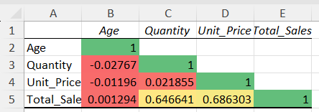
Figure 6.3: Correlation Matrix Heatmap
7. Static Dashboard
A static dashboard was created in Microsoft Excel to present the key findings of the sales data in a simple and organized format. The dashboard was designed using the Pivot Tables, Pivot Charts, and analysis performed during the Exploratory Data Analysis.
The dashboard includes the following Key Performance Indicators (KPIs):
- Total Revenue
- Total Orders
- Average Order Value
- Total Quantity Sold
The dashboard also includes the following charts:
- Histogram
- Gender-wise Sales Analysis
- Category-wise Sales Analysis
- City-wise Sales Analysis
- Product-wise Sales Analysis
- Scatter Plot
The dashboard provides a clear overview of the sales performance and helps understand important business insights at a glance.
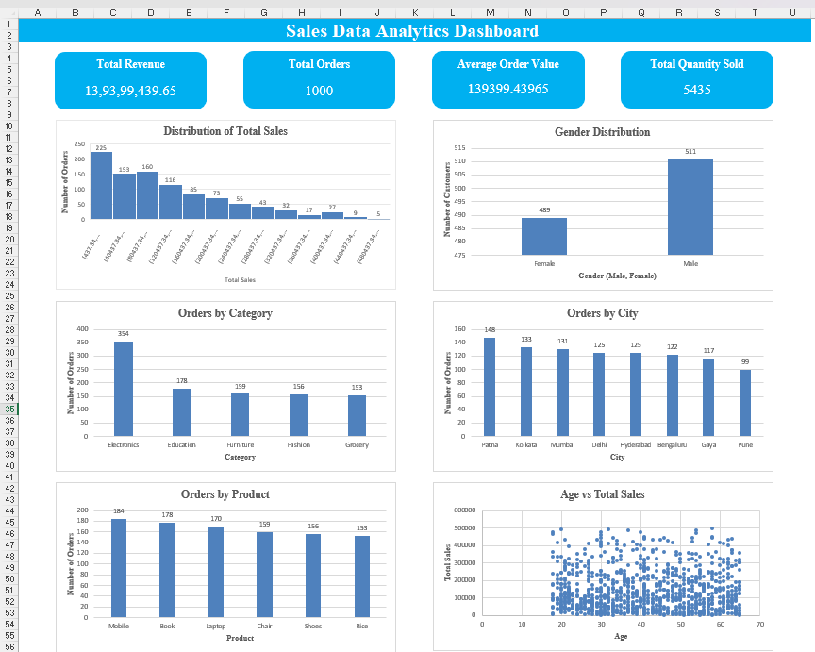Figure 7: Static Dashboard
8. Final Output
The following files were generated during the Task 2:
- ApexPlanet_DataAnalytics_Task2.xlsx
- Excel Workbook containing the following worksheets:
- Cleaned_Data
- Descriptive_Statistics
- Gender_Analysis
- Category_Analysis
- City_Analysis
- Product_Analysis
- Histogram
- Scatter Plot
- Correlation_Data
- Correlation_Matrix_Heatmap
- Dashboard
- Task2_SQLQueries.sql
- Task2_Report.docx
- Task2_Report.pdf
9. Conclusion
In this task, Exploratory Data Analysis (EDA) was performed on the cleaned sales dataset using Microsoft Excel. Different analyses such as descriptive statistics, Pivot Tables, Pivot Charts, histogram analysis, scatter plot, correlation matrix, and heatmap were created to understand the sales data and identify useful business insights.
The cleaned dataset was also imported into Microsoft SQL Server Management Studio (SSMS), where SQL queries were executed to answer business-related questions. Finally, a static dashboard was created to present the important KPIs and visualizations in a simple and organized manner.
This task improved my understanding of Exploratory Data Analysis, SQL, data visualization, and dashboard creation. It also helped me gain practical experience in analysing business data and presenting insights effectively.

